**VIVEKANAND EDUCATION SOCIETY’S INSTITUTE OF TECHNOLOGY**

**An Autonomous Institute Affiliated to University of Mumbai**

**Department of Computer Engineering**



Project Report on

MISSING SUBSTANCE (CARS) DETECTION

In partial fulfillment of the Fourth Year, Bachelor of Engineering (B.E.) Degree in Computer Engineering at the University of Mumbai Academic Year 2023-24

**Submitted by**

TANAY PHATAK (D17-B, Roll no - 56)

GAUTAM WADHWANI (D17-B, Roll no - 71)

TANMAY THAKARE (D17-B, Roll no - 67)

SAKSHI BHOJWANI (D17-B, Roll no - 09)

**Project Mentor**

Mrs. PRIYA R L

DR. SHARMILA SENGUPTA

(2023-24)

**VIVEKANAND EDUCATION SOCIETY’S INSTITUTE OF TECHNOLOGY**

**An Autonomous Institute Affiliated to University of Mumbai**

**Department of Computer Engineering**



**Certificate**

This is to certify that***Tanay Phatak, Gautam Wadhwani, Tanmay Thakare, Sakshi Bhojwani*** of Fourth Year Computer Engineering studying under the University of Mumbai have satisfactorily completed the project on *“****Missing Substance(Cars) Detection****”* as a part of their coursework of PROJECT-II for Semester-VIII under the guidance of their mentor ***Prof.* *Mrs. Priya R L and Prof. Dr. Sharmila Sengupta*** in the year 2023-24 .

This project report entitled **“*Missing Substance(Cars) Detection”***  by ***Tanay Phatak, Gautam Wadhwani, Tanmay Thakare, Sakshi Bhojwani*** is approved for the degree of ***Computer Engineering(B.E).***

| Programme Outcomes | Grade |
| --- | --- |
| PO1,PO2,PO3,PO4,PO5,PO6,PO7,  PO8, PO9, PO10, PO11, PO12  PSO1, PSO2 |  |

Date:

Project Guide:

------------------------------------------

**TIFR Certificate**



**Project Report Approval**

**For**

**B. E (Computer Engineering)**

This thesis/dissertation/project report entitled ***MISSING SUBSTANCE (CARS) DETECTION*** by ***TANAY PHATAK, GAUTAM WADHWANI,TANMAY THAKARE, SAKSHI BHOJWANI*** is approved for the degree of ***Computer Engineering(B.E).***

Internal Examiner

---------------------------------------------

External Examiner

---------------------------------------------

Head of the Department

-----------------------------------------------

Principal

-----------------------------------------------

Date:

Place:

# Declaration

We declare that this written submission represents our ideas in our own words and where others' ideas or words have been included, we have adequately cited and referenced the original sources. We also declare that we have adhered to all principles of academic honesty and integrity and have not misrepresented or fabricated or falsified any idea/data/fact/source in our submission. We understand that any violation of the above will be cause for disciplinary action by the Institute and can also evoke penal action from the sources which have thus not been properly cited or from whom proper permission has not been taken when needed.

| -----------------------------------------  (Signature)  -----------------------------------------  (Name of student and Roll No.) | -----------------------------------------  (Signature)  -----------------------------------------  (Name of student and Roll No.) |
| --- | --- |
| -----------------------------------------  (Signature)  -----------------------------------------  (Name of student and Roll No.) | -----------------------------------------  (Signature)  -----------------------------------------  (Name of student and Roll No.) |

Date:

# 

# 

# 

# 

# 

# 

# ACKNOWLEDGEMENT

We are thankful to our college Vivekanand Education Society’s Institute of Technology for considering our project and extending help at all stages needed during our work of collecting information regarding the project.

It gives us immense pleasure to express our deep and sincere gratitude to **Prof. Mrs. Priya R L and Prof. Dr. Sharmila Sengupta**  for their kind help and valuable advice during the development of project synopsis and for her guidance and suggestions.

We are deeply indebted to Head of the Computer Department **Dr.(Mrs.) Nupur Giri** and our Principal **Dr. (Mrs.) J.M. Nair,** for giving us this valuable opportunity to do this project.

We express our hearty thanks to them for their assistance without which it would have been difficult in finishing this project synopsis and project review successfully.

We convey our deep sense of gratitude to all teaching and non-teaching staff for their constant encouragement, support and selfless help throughout the project work. It is a great pleasure to acknowledge the help and suggestion, which we received from the Department of Computer Engineering.

We wish to express our profound thanks to all those who helped us in gathering information about the project. Our families too have provided moral support and encouragement several times.

**Computer Engineering Department**

**COURSE OUTCOMES FOR B.E PROJECT**

| **Course Outcome** | **Description of the Course Outcome** |
| --- | --- |
| CO 1 | Able to apply the relevant engineering concepts, knowledge and skills towards the project. |
| CO2 | Able to identify, formulate and interpret the various relevant research papers and to determine the problem. |
| CO 3 | Able to apply the engineering concepts towards designing solutions for the problem. |
| CO 4 | Able to interpret the data and datasets to be utilized. |
| CO 5 | Able to create, select and apply appropriate technologies, techniques, resources and tools for the project. |
| CO 6 | Able to apply ethical, professional policies and principles towards societal, environmental, safety and cultural benefit. |
| CO 7 | Able to function effectively as an individual, and as a member of a team, allocating roles with clear lines of responsibility and accountability. |
| CO 8 | Able to write effective reports, design documents and make effective presentations. |
| CO 9 | Able to apply engineering and management principles to the project as a team member. |
| CO 10 | Able to apply the project domain knowledge to sharpen one’s competency. |
| CO 11 | Able to develop professional, presentational, balanced and structured approach towards project development. |
| CO 12 | Able to adopt skills, languages, environment and platforms for creating innovative solutions for the project. |

# Chapter Index

| **Chapter No** | **Title** | **Page No** |
| --- | --- | --- |
|  | **Abstract** | **10** |
| **1** | **Introduction** | **11** |
| 1.1 | Introduction | 11 |
| 1.2 | Motivation | 12 |
| 1.3 | Problem Definition | 12 |
| 1.4 | Relevance of the Project | 13 |
| **2** | **Literature Survey** | **14** |
| 2.1 | Research Papers referred | 14 |
| 2.2 | Existing Systems | 19 |
| 2.3 | Lacuna in the existing system | 20 |
| **3** | **Requirements** | **21** |
| 3.1 | Proposed Model | 21 |
| 3.2 | Functional Requirements | 22 |
| 3.3 | Non-Functional Requirements | 22 |
| 3.4 | Hardware and Software Requirements | 23 |
| 3.5 | Technology and Tools Utilization | 23 |
| 3.6 | Constraints of Working | 23 |
| **4** | **Proposed Design** | **24** |
| 4.1 | Block Diagram of the proposed Design | 24 |
| 4.2 | Modular Diagram | 26 |
| 4.3 | Methodology Used | 30 |
| 5 | **Testing of the Proposed System** | **32** |
| 5.1 | Types of tests Considered | 32 |
| 5.2 | Inference drawn from the test cases | 33 |
| **6** | **Results and Discussions** | **34** |
| **7** | **Conclusion** | **39** |
|  | **References** | **40** |
|  | **Appendix** | **41** |
|  | **Achievements** | **41** |

# List of Figures

| **Fig No** | **Title** | **Page No** |
| --- | --- | --- |
| 1 | **Conceptual diagram** | 23 |
| 2 | **Modular Diagram of Complaint Application Module, Video Processing Module, Object Detection Module and Feature Extraction Module** | 26 |
| 3 | **Modular Diagram of Tracking Module** | 28 |
| 4 | **Modular Diagram of Re-identification Module** | 29 |
| 5 | **Vector mathematical technique for camera selection** | 31 |
| 6 | **Video Frame and Cropped image of detected car from input frame** | 35 |
| 7 | **Cropped number plate image from cropped car image** | 35 |
| 8 | **OCR Result on cropped number plate image (before and after deskewing)** | 35 |
| 9 | **Training and validation results for car model prediction model.** | 36 |
| 10 | **Results of car model recognition** | 36 |
| 11 | **Training and validation results for car color recognition model** | 37 |
| 12 | **Results of car color recognition** | 37 |
| 13 | **Tracking results of DeepSORT** | 38 |

# List of Tables

| **Table No** | **Title** | **Page No** |
| --- | --- | --- |
| 1 | Analysis of Bicubic Enhancement | 34 |
| 2 | Analysis of EDSR Super Resolution | 34 |
| 3 | Analysis of LapSRN Super Resolution | 34 |
| 4 | CPU vs GPU execution time comparison | 38 |

# Abstract

Vehicle theft is a pervasive issue globally, with authorities facing significant challenges in tracking stolen vehicles due to the absence of standard GPS trackers and limited internet connectivity in many vehicles. Moreover, environmental factors such as dense foliage or mountainous terrain can further impede accurate location tracking using GPS signals. To overcome these obstacles, a novel approach proposes harnessing existing CCTV networks to monitor and trace stolen vehicles. By employing advanced computer vision and deep learning techniques, this solution aims to extract relevant features from CCTV footage, including the vehicle's registration number, color, and model. Leveraging these features, the system can identify the stolen vehicle and track its movement across different camera feeds, thus facilitating a more efficient and effective recovery process.

This proposed tracking solution capitalizes on the infrastructure already in place, eliminating the need for additional hardware installation in vehicles. By analyzing footage from various CCTV sources and utilizing vector mathematical techniques, the system can determine the next camera to scan, ensuring seamless tracking of the stolen vehicle's route. The integration of geolocation data from CCTV cameras aids in plotting the vehicle's path on a map, providing authorities with valuable insights into its movements. This innovative approach not only accelerates response times but also enhances the likelihood of successful vehicle recovery, all while preserving data privacy considerations.

# Chapter 1: Introduction

## 1.1 Introduction

In an era defined by technological prowess and interconnectedness, Closed-Circuit Television (CCTV) systems have become an omnipresent aspect of our surroundings. These unobtrusive sentinels silently monitor various environments, from bustling city streets to intimate indoor spaces, capturing a wealth of visual data. Among their multifaceted applications, one particularly compelling avenue is the utilization of CCTV recordings for detecting missing objects or individuals.

The timely and accurate identification of missing objects or persons is a crucial concern spanning diverse domains, from security and law enforcement to retail and public safety. Leveraging the remarkable advancements in computer vision, artificial intelligence, and pattern recognition, a novel approach has emerged: harnessing the potential of CCTV footage to facilitate the detection process. This innovative fusion of technology and practicality holds the promise of revolutionizing how we locate and recover lost items or individuals, saving time, and resources, and ensuring peace of mind.

This exploration delves into the evolving landscape of object and person detection through the lens of CCTV recordings. By investigating the unique challenges posed by this intricate task, examining the methodologies that underpin its development, and surveying the array of potential solutions, we embark on a journey to unlock the transformative potential of this burgeoning field. As we navigate through the intricacies of algorithms, image analysis, and real-world implementation, we shed light on how cutting-edge technology can be harnessed to address a fundamental aspect of modern society - the swift and efficient recovery of what has gone missing.

## 1.2 Motivation

**Rising Vehicle Theft Rates:** Start by highlighting the increasing incidents of vehicle thefts, not only as a localized problem but also as a global issue. Emphasize statistics or trends that demonstrate the growing concern around missing vehicles.

**Economic Loss and Public Safety:** Discuss the economic impact of vehicle thefts on individuals and society. Highlight how stolen vehicles lead to financial losses for individuals and insurance companies. Also, address the potential public safety concerns when stolen vehicles are misused for criminal activities.

**Urbanization and Surveillance Systems:** In urban areas, where surveillance systems like CCTV cameras are extensively deployed, mention how the sheer volume of surveillance data can overwhelm law enforcement agencies. This sets the stage for the need for an automated solution like the one proposed in your project.

**Advancements in Computer Vision:** Acknowledge the rapid advancements in computer vision and artificial intelligence technologies. Explain how these technological advances provide new opportunities to tackle complex problems like missing vehicle detection with greater accuracy and efficiency.

**Potential Applications:** Discuss the practical applications of your project beyond vehicle theft prevention. For example, highlight how your system could be adapted for parking management, traffic monitoring, or even autonomous vehicle navigation in real-world urban environments.

**Data Privacy and Ethical Concerns:** Touch upon the importance of safeguarding data privacy, an essential aspect of your project's solution. Mention how your approach aims to balance the need for efficient detection with ethical considerations regarding surveillance and data protection.

## 1.3 Problem Definition

In recent years, the escalating rate of vehicle thefts has emerged as a significant societal concern, posing economic losses and public safety threats on multiple fronts. This problem is particularly pronounced in urban areas, where dense populations and extensive surveillance systems coexist. Law enforcement agencies grapple with the daunting task of managing the overwhelming volume of surveillance data generated by Closed-Circuit Television (CCTV) systems. As vehicles go missing or are stolen, investigators face the daunting challenge of swiftly and accurately identifying, locating, and recovering these missing assets.

## 1.4 Relevance of the Project

The significance of the project lies in its ability to address critical societal and technological challenges, offering solutions that have far-reaching implications across various domains. Below are the key aspects that highlight the project's relevance:

**Tackling a Growing Social Issue**: The project directly addresses the increasing rate of vehicle thefts, which has become a pressing social issue with economic, safety, and security implications. By developing a missing vehicle detection system, we contribute to reducing these incidents and their associated consequences.

**Enhancing Public Safety**: Stolen vehicles can be used for criminal activities, accidents, or other unlawful purposes, posing a threat to public safety. The project's potential to swiftly locate and recover missing vehicles can significantly enhance public safety and reduce the risks associated with stolen vehicles.

**Economic Impact**: Vehicle thefts result in substantial financial losses for individuals and insurance companies. An effective missing vehicle detection system can help mitigate these economic losses, making it financially relevant to vehicle owners and the insurance industry.

**Optimizing Law Enforcement Resources**: The overloaded urban surveillance systems and the need for manual video analysis strain the resources of law enforcement agencies. Our project aims to automate and streamline the process, allowing agencies to allocate their resources more efficiently.

**Privacy and Ethics**: As surveillance systems become more prevalent, issues related to data privacy and ethics come to the forefront. The project's consideration of these ethical concerns demonstrates its relevance in ensuring responsible and respectful use of surveillance data.

**Potential for Multiple Applications**: Beyond missing vehicle detection, the project has the potential for broader applications, including parking management, traffic monitoring, and autonomous vehicle navigation. These applications make the project relevant in various contexts.

**Societal Well-being**: Ultimately, the project's ability to contribute to societal well-being by reducing vehicle thefts, enhancing public safety, and optimizing resource allocation underscores its relevance and importance.

# Chapter 2: Literature Survey

## 2.1 Research Papers referred

### A. Books

**1. Object Re-Identification Based on Deep Learning (2019)**

**Methodology:** Preprocess the vehicle image datasets (VeRi-776, VRID-1, VehicleID) by applying data augmentation techniques to increase the diversity and size of the training data. Utilize transfer learning by fine-tuning the pre-trained VGG-16 convolutional neural network on the vehicle image datasets, leveraging its powerful feature extraction capabilities for vehicle representation learning.

**Inference:** The system aims to locate and track cars using CCTV footage and re-identify them, even in cases where the vehicles do not have visible number plates. The performance metrics reported are HIT@1 and HIT@5, which represent the accuracy of correctly identifying the top-ranked match and the correct match within the top 5 ranks, respectively.

The results show that when using only the VGG architecture or a combination of VGG with either S (SoftmaxLoss) or T (Triplet Loss), the HIT@1 and HIT@5 values are 72.94% and 86.83%, respectively. However, when combining VGG with both S and T components, the performance significantly improves, with HIT@1 reaching 89.75% and HIT@5 reaching an impressive 95.05%.

This suggests that integrating softmax loss, triplet loss, and visual information through the VGG architecture and additional components (S and T) enhances the system's ability to accurately re-identify and track vehicles, even without relying solely on number plate recognition. The synergistic combination of these components likely captures more comprehensive features and contextual information, leading to superior performance in challenging scenarios where number plates are not available or visible.

**Limitations:** VGG-16 is computationally expensive due to its large number of parameters and dense connections. EfficientNet achieves comparable performance with significantly fewer computational resources, making it more suitable for resource-constrained applications.

**2. CNN based missing object detection (2023)**

**Methodology:** The author employs a CNN-based approach for missing object detection, trained on a dataset comprising 500 images. The method is compared against GAN and Texture analysis techniques.

**Inference**: The author’s CNN-based approach demonstrates promising results in detecting missing objects, even with a relatively small training dataset of 500 images. However, further training with more complex images is necessary to assess its performance comprehensively. By comparing against established methods like GAN and Texture analysis, the efficacy of the CNN-based approach is highlighted, suggesting its potential for real-world applications in missing object detection scenarios.

**Limitations:** The limited size of the training dataset (500 images) may constrain the model's ability to generalize effectively to more complex scenarios. Further exploration with larger and more diverse datasets is warranted to evaluate the robustness and scalability of the proposed CNN-based approach.

**3. Corner-Point and Foreground-Area IoU Loss: Better Localization of Small Objects in Bounding Box Regression(2023)**

**Methodology:** The authors introduce the Corner Point and Foreground Area Intersection over the Union (CFIoU) loss function to enhance bounding box regression for small object localization. Evaluation is conducted using datasets vizDrone-DET2019 and SODA-D, with comparison against Anchor-based YOLOv5 and Anchor-free YOLOv8 models.

**Inference:** The proposed CFIoU loss function exhibits improved performance in bounding box regression, particularly for small object localization, as evidenced by higher Recall values and Mean Average Precision (MAP) scores at various IoU thresholds. However, the model may produce multiple bounding boxes in scenarios with high overlapping boxes (>70%), complicating object distinction.

**Limitations:** Despite the advancements in small object localization offered by CFIoU, the model's performance may degrade in cases of significant box overlap, leading to ambiguity in object identification. Further refinement of the model architecture or post-processing techniques may be necessary to address this issue effectively.

### B. Journals

**1. Deep Learning Based Traffic Surveillance System For Missing and Suspicious Car Detection(2020)**

**Methodology:** Leverage Tesseract OCR for efficient text extraction from surveillance footage and GAN models for data augmentation, enhancing the training dataset with synthetic images to improve the accuracy of the missing vehicle detection system.

**Inference:** The system leverages CCTV camera footage to aid police and investigation teams in locating and identifying stolen or suspicious vehicles. By analyzing the surveillance footage, the system has demonstrated an impressive accuracy rate of 87% in correctly identifying the target vehicles of interest, rather than presenting false positives or irrelevant candidates. This high accuracy rate suggests that the system effectively processes and interprets the visual data from CCTV cameras, enabling law enforcement agencies to streamline their search efforts and allocate resources more efficiently. However, there is still room for improvement to further enhance the system's accuracy and reliability, potentially through advancements in computer vision algorithms, data preprocessing techniques, or the integration of additional data sources.

**Limitations:** The process of deskewing or straightening the orientation of number plates in the captured images is often a trial-and-error approach, which can be prone to errors. This ad-hoc method increases the likelihood of misreading or misinterpreting the characters on the number plates, leading to inaccurate vehicle identification. A more robust and systematic approach to number plate deskewing is needed to minimize misreadings and improve the overall accuracy of the system.

**2. Intelligent Camera Selection Decisions for Target Tracking in a Camera Network(2022)**

**Methodology:** The methodology employs a Deep Q-network (DQN) architecture to learn an optimal policy for intelligent camera selection in a camera network for target tracking. The DQN is trained on datasets like NLPR MCT, DukeMTMC, CityFlow, and WNMF. An LSTM-based autoencoder extracts robust feature representations from camera feeds, enabling efficient tracking and handover between cameras. The learned DQN policy, combined with the autoencoder features, intelligently selects appropriate cameras for seamless target tracking across the network.

**Inference:** The approach leverages state-representation learning and reinforcement learning to improve camera selection efficiency for target tracking across large camera networks. The LSTM-based autoencoder learns robust feature representations, enabling efficient tracking and handover between cameras. The DQN architecture learns an optimal policy for intelligent camera selection, optimizing resource utilization. With a Top-1 accuracy of 93.28% and a Top-2 accuracy of 96.27%, the system demonstrates high tracking performance while reducing training time and false alarms, allowing scalability to larger networks.

**Limitations:** No results were provided to evaluate the time complexities of the proposed approach, nor was there any information given on how the size of the camera network impacts the time required for training the models and performing inference during target tracking.

**3. Recognition Design Of License Plate and Car Type Using Tesseract Ocr And Emgucv**

**Methodology:** Preprocess vehicle images, detect license plates using EmguCV's object detection, segment characters, recognize plate text with Tesseract OCR, classify car type through EmguCV's machine learning models, and post-process results for robust license plate and car type recognition.

**Inference:** The research aimed to design and implement software capable of recognizing license plates and car types from images. The implemented solution, leveraging Tesseract OCR and EmguCV, achieved an accuracy of 80.223% for license plate recognition and 75% for car type classification. While these results are promising, there is room for improvement, potentially by exploring advanced techniques, data augmentation strategies, or incorporating additional contextual information. However, details about the specific algorithms, datasets, and evaluation methodologies used are not provided, making it difficult to assess the generalizability of the results or identify areas for further optimization.

**Limitation:** Tesseract OCR typically treats each character independently and may not consider contextual information when recognizing characters. This can lead to errors, especially in cases where characters are ambiguous or similar-looking.

**4. Vehicle model recognition using geometry and appearance of car emblems from rear-view images**

**Methodology:** The proposed method utilizes HOG features and SVMs to recognize vehicle models from rear-view images via emblem analysis. Emblem regions are localized, described with HOG descriptors, and used to train a multi-class SVM classifier. During inference, HOG features of emblem regions in test images are fed into the trained SVM for model prediction.

**Inference:** The vehicle model recognition approach presented focuses on analyzing the geometry and appearance of car emblems in rear-view images. Achieving an impressive overall accuracy of 93.75%, the method demonstrates robustness in discerning between different vehicle models based on emblem characteristics. By leveraging Histogram of Oriented Gradients (HOG) features and Support Vector Machines (SVMs), emblem regions are effectively localized and described, facilitating accurate model predictions. This high accuracy underscores the effectiveness of emblem analysis as a reliable method for vehicle model recognition in rear-view images, with potential applications in various domains such as automated surveillance and traffic management.

**Limitation:** Restricting identification to the rear-view geometry of car models may not provide comprehensive recognition in scenarios where frontal or side views are crucial, limiting its overall utility and accuracy.

**5. TextBoxes: A Fast Text Detector with a Single Deep Neural Network. (2016)**

**Methodology**: The author presents the "TextBoxes" algorithm, focusing on creating a single deep neural network capable of accurately detecting text in natural scenes. The research compares TextBoxes with CRNN, evaluating their performance across Text Localization Accuracy, Efficiency, Word Spotting Performance, and End-to-End Text Recognition metrics.

**Inference**: TextBoxes demonstrates commendable efficiency and competitive performance across various text detection tasks, offering promising results in end-to-end trainable architectures. However, it encounters challenges in handling certain difficult scenarios, such as overexposure and instances of large character spacing, which may affect its robustness in real-world applications.

**Limitations**: Despite its overall effectiveness, TextBoxes exhibits shortcomings in addressing specific

complex cases, including overexposure and large character spacing. Further refinement or augmentation of the algorithm may be necessary to enhance its adaptability to diverse and challenging text detection scenarios.

**6. Character Region Awareness for Text Detection (2019)**

**Methodology**: The authors present a text detection approach named "Character Region Awareness" designed to extract text from images regardless of orientation, including curved, skewed, or disorganized text. The research evaluates its performance across datasets such as TotalText, CTW-1500, ICDAR2013, ICDAR2015, ICDAR2017, and MSRA-TD500, utilizing VGG and U-net architectures to compute region and affinity scores.

**Inference**: The proposed method demonstrates robustness in identifying and extracting text from images with various orientations, achieving competitive performance across multiple benchmark datasets. By employing a weakly supervised approach that generates pseudo-ground truths from an interim model, the method tackles challenges associated with training character-level models, particularly in scenarios with vague or noisy guidance.

**Limitations**: Despite its efficacy, the reliance on weakly supervised learning may introduce limitations in training character-level models, potentially leading to ambiguous or noisy results, especially in tasks like text generation or recognition. Further research may be needed to address these challenges and enhance the model's performance in such scenarios.

**7. Materials for the study of the locus operandi in the search for missing persons in Italy**

**Methodology**: The authors utilize Geographic Profiling, commonly employed in criminology and forensic science, to detect missing individuals with illnesses or mental health issues in Italy. They leverage Geographic Information System (GIS) data, including crime reports, and employ techniques such as Thiessen polygons, Voronoi diagrams, and Delaunay triangulations to analyze geographical patterns associated with missing person cases.

**Inference**: The study showcases three case studies where each employs one of the aforementioned algorithms to analyze geographical data related to missing persons in Italy. These cases involve individuals with mental health issues, amnesia, and breathing problems, highlighting the versatility of the approach in addressing various scenarios. However, despite the methodology's potential, the tests occurred during the lockdown period, limiting the involvement of forensic teams and resulting in delays that ultimately led to the unfortunate discovery of the missing persons deceased.

**Limitations**: The study faces limitations due to the constrained circumstances during the tests, where only

police personnel were available to assist forensic teams, potentially hindering the efficiency of search and rescue operations. Additionally, while Geographic Profiling offers valuable insights into locating missing individuals, its effectiveness may be influenced by factors such as data availability, geographical coverage, and resource constraints, which warrant further investigation for enhanced outcomes in real-world scenarios.

## 2.2 Exiting Systems

Finding a stolen car can be stressful, and it often takes time to locate the vehicle once lost. [21] The State of Global Safety and Security survey found that 39% of respondents had experienced vehicle theft, making it the fourth most commonly reported type of crime. Without adequate protection, the risk of car theft is significantly higher. There are many ways in which existing systems help to find the stolen cars.

**Locate by VIN ID**

If someone visits a repair shop, the VIN of the car is tracked and obtained by the police. If a thief has legitimate maintenance or repairs performed on a stolen vehicle, they will be required to provide the car's VIN. Obtaining the VIN history of the vehicle can help uncover any actions linked to the thief, which can then be shared with the police.

### 

### Track a Stolen Car With Bluetooth

To check if a car is within Bluetooth range, attempt to establish a connection between the car and a phone. If the connection fails, it could be due to Bluetooth being turned off or the car not being in proximity. Bluetooth trackers designed for cars exist, but their reliability is limited because Bluetooth has a very limited range. Additionally, thieves can easily disable a Bluetooth connection once they steal the vehicle.

### Locate a Stolen Car With a GPS Tracker

Contemporary vehicles come equipped with integrated GPS tracking systems linked to satellites. When paired with a smart device, it is possible to monitor a car's location through the associated mobile application. For cars lacking factory-installed GPS trackers, it is feasible to install an aftermarket GPS tracking device. These aftermarket devices can be affixed to the underside of the vehicle or concealed in the trunk, and similar to integrated GPS trackers, they establish a connection with a mobile app.

## 2.3. Lacuna in the existing systems

While the current systems can locate missing cars, they still face significant unresolved challenges. Utilizing the VIN method for car retrieval is a viable approach; however, it has limitations. One notable challenge is that if the stolen car moves beyond the Bluetooth range, it becomes impossible to track.

Many modern cars are equipped with GPS systems, which should theoretically aid in tracking. Nevertheless, there are vulnerabilities associated with GPS tracking. For instance, if a thief manages to tamper with or remove the GPS device, tracking via GPS becomes ineffective.

# Chapter 3: Requirements

## 3.1 Proposed model

In our quest to enhance missing vehicle detection using CCTV recordings, a comprehensive and innovative model will be developed. This model will harness the power of computer vision, machine learning, and artificial intelligence to achieve accurate and efficient results. Below are the key components and elements of the proposed model:

* **Substance Detection Algorithms**: The foundation of our model will be built upon state-of-the-art substance detection algorithms. We will explore and evaluate advanced techniques such as YOLO (You Only Look Once), Faster R-CNN (Region Convolutional Neural Network), or similar deep learning-based models. These algorithms excel in object detection tasks, and we will adapt them to the specific task of identifying vehicles within CCTV footage.
* **Training Data**: To train our substance detection model effectively, we will assemble a diverse dataset of CCTV recordings containing both scenes with vehicles and scenes without vehicles. This dataset will serve as the basis for supervised learning, enabling the model to learn representative features of vehicles.
* **Frame Comparison Mechanism**: To account for dynamic object motion and track missing vehicles, our model will incorporate a frame comparison mechanism. This module will employ frame differencing techniques, subtracting pixel values between consecutive frames to identify regions of motion. Thresholding and filtering strategies will be applied to distinguish meaningful motion from noise, providing a refined understanding of vehicle trajectories.
* **Integration of Substance Detection and Frame Comparison**: A crucial aspect of our proposed model is the seamless fusion of substance detection and frame comparison results. By aligning the detected vehicles from the substance detection phase with the motion trajectories obtained through frame comparison, our model aims to achieve more accurate and robust vehicle motion detection. This integration will enhance the overall reliability of the system by minimizing false positives and optimizing tracking precision.
* **Real-time Processing**: Our model will be designed for real-time processing of CCTV footage, ensuring timely detection and tracking of missing vehicles. This capability is essential for enabling swift response from law enforcement or security personnel.

## 3.2 Functional Requirements

* **Video Input Compatibility**: The system should be able to process video footage from various types of CCTV cameras, ensuring compatibility with common video formats.
* **Real-time Detection**: The system must be capable of detecting missing vehicles in real-time, as soon as they go missing or are stolen.
* **Vehicle Identification**: It should accurately identify vehicles within the video frames, distinguishing them from other objects or backgrounds.
* **Motion Tracking**: The system should track the motion of vehicles within the video, allowing for the monitoring of vehicle trajectories.
* **Alert Mechanism**: When a missing vehicle is detected, the system should trigger an alert or notification to relevant authorities or personnel.
* **User-Friendly Interface**: It should have an easy-to-use interface for configuring settings, reviewing alerts, and accessing historical data.

## 3.3 Non-Functional Requirements

* **Performance**: The system should work quickly and efficiently, even with a large amount of surveillance data, to ensure timely detection and response to missing vehicles.
* **Accuracy**: It must accurately identify missing vehicles and minimize false alarms to maintain the trustworthiness of the system.
* **Reliability**: The system should work consistently without unexpected downtime or errors, ensuring it's always available for monitoring.
* **Usability**: Users, including law enforcement personnel, should find the system easy to navigate and use, even without specialized training.
* **Security**: Access to the system and its data must be secure to prevent unauthorized use or data breaches.
* **Scalability**: The system should be able to handle an increasing amount of surveillance data as the number of cameras or locations grows.
* **Privacy**: It should respect the privacy of individuals in surveillance footage by protecting their identities and sensitive information.
* **Compatibility**: The system should work seamlessly with various types of CCTV cameras and video formats commonly used in surveillance.
* **Availability:** The system should maintain a high uptime percentage, with minimal planned and unplanned downtime, to ensure continuous monitoring and detection of missing vehicles.

## 3.4 Hardware & Software Requirements

**Hardware**

* Intel Core i5 or higher
* 8 GB RAM or more
* GPU (CUDA and CUDnn)
* Storage space (Min. 10 GB free space)
* CCTV cameras

**Software**

* Python 3.8 and above
* Ubuntu 20.04 LTS or higher

**External Requirements**

* CCTV System Information (eg. camera geo-locations)
* CCTV Recordings

## 3.5 Technology and Tools Utilized

**Libraries**

* YOLO
* PyQt
* TensorFlow / PyTorch
* EasyOCR

**Models / Algorithms**

* Super Resolution (EDSR, LapSRN, etc.)
* Optical Character Recognition

**Code Editor**

* VSCode

## 3.6 Constraints of working

* No GPS tracker was fitted to the missing car.
* No internet connectivity with the missing car.

# Chapter 4: Proposed Design

## 4.1 Block Diagram of the proposed system

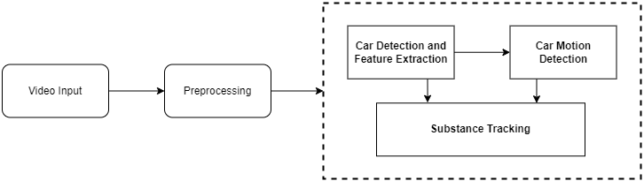

**Figure 1: Conceptual diagram**

In Figure 4.1, the system captures video footage from CCTV cameras as its input. This video data goes through a preprocessing step where it is converted into individual frames, and you can specify the frame rate for this conversion. Once the preprocessing is done, these frames are then fed into the model.

The model's primary task is to identify cars within these frames. If it successfully detects cars in the front position, the system proceeds to the next step, which involves creating bounding boxes around each car and storing cropped images of each identified car.

Additionally, the model is capable of determining the direction in which these objects (cars) are moving from the beginning of the video to the end. The frame rate also plays a crucial role here; if the cars are moving at high speeds, the frame rate will need to be higher to capture the motion accurately, and conversely, a lower frame rate might suffice for slower-moving cars.

**Video Preprocessing:**

Performs the task of accepting the video and processing it to convert it into a form that can be used for further processing. The video is converted into frames such that each frame can be processed independently to extract useful information about the car present in the video and identify the subject car. The extracted frames are further processed to detect cars in them using the YOLOv7 object detection model. The bounding box coordinates produced by the YOLOv7 model are used to crop the sections of the frame that contain a car. These cropped images are then sent for feature extraction where we try to find and match features of each detected car to find the subject car.

**Feature Extraction:**

Responsible for preparing potential candidates and targets for re-identification. It computes feature vectors for candidates and targets, which are essential for re-identification. Feature extraction is resource-intensive and is performed selectively on the most promising candidates. Subscribes to video frames (optional) and receives candidates and targets from the candidate filtering module. It generates candidate and target locations along with identifying feature vectors.

**Re-Identification:**

It handles the final re-identification process. Utilizes the feature vectors calculated in the previous module for comparison. Compare the active target with all candidates from each camera. Provides a sorted list of potential candidates along with different scores for each candidate. Subscribes to video frames (optional) and receives candidates and targets from the Feature Extraction module. Outputs new target announcements and re-identification results.

**Cuda Programming:**

We utilize the fast performance and parallel processing nature of Cuda programming to speed up the process. We perform object detection using the YOLOv7 model that runs on a Cuda machine that improves the performance of detecting cars in each frame. Further we perform the predictions of car model and color using a Cuda machine. Finally, the tracking module uses Cuda for fast and efficient path tracking and to implement the DeepSORT algorithm.

## 4.2 Modular diagram

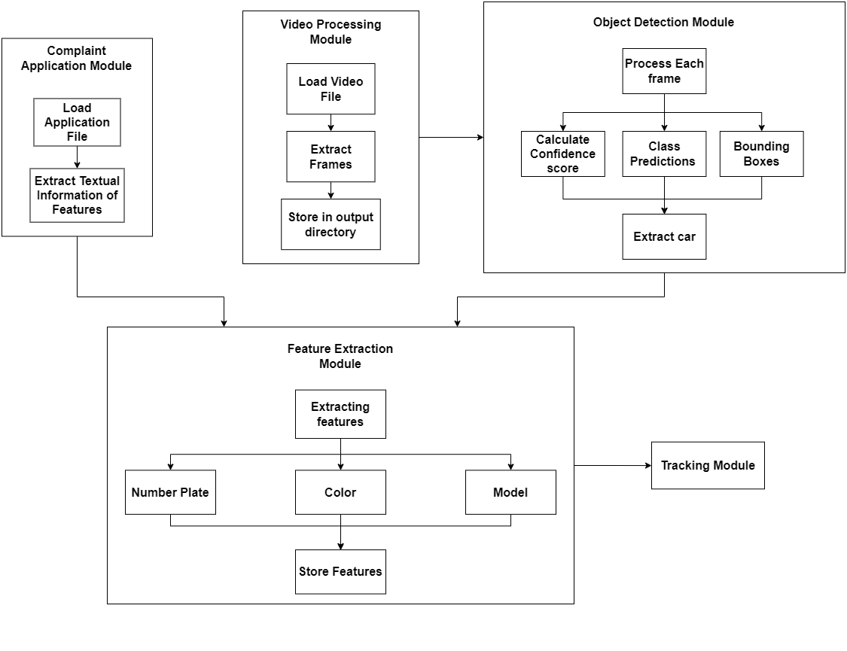

**Figure 2: Modular Diagram of Complaint Application Module, Video Processing Module, Object Detection Module and Feature Extraction Module**

The proposed solution uses five modules, as shown in Figure 1. The applicant of the complaint uses an online form to enter the necessary details to initiate the search process. The form includes fields like Car Model, Car color, License plate number, an optional field to upload the image of the car, the approximate timestamp at which the car has gone missing and the approximate location of the car. The textual information is mapped with the pre-fed image data to produce a reference image of the stolen car. This information is stored for further usage in the search process.

Based on the location and timestamp of theft, the video processing module extracts the videos of appropriate intervals and locations from the CCTV systems, preprocesses them and converts them into frames for further analysis.

**Video Preprocessing / Object Detection Module:**

The extracted videos are converted into frames in order to process each frame individually and extract useful information about the cars present in the video. The Object Detection Module uses the extracted frames to identify cars using the YOLOv7 pre-trained model. The YOLOv7 internally calculates the confidence score, performs class prediction and assigns bounding boxes to identify all the candidate cars in the frame.

* **Confidence Score Calculation:** It calculates a confidence score for each object or potential car within the frame. This score reflects the module's level of certainty that a particular region of the image contains a car. Higher confidence scores indicate a stronger belief that an object is a car.
* **Class Prediction:** The module predicts the class of each object detected in the frame. In this specific case, the class of interest is "car." The module determines whether each object corresponds to a car or not.
* **Bounding Box Generation:** Once an object is identified as a car, the module outlines or highlights it by drawing a bounding box around it. This bounding box visually encloses the detected car within the frame, making it easily distinguishable.

By performing the tasks mentioned above, the Object Detection Module identifies all candidate cars within the video frame. These candidates are regions within the image where the module has detected cars based on its analysis.Further, the identified car images are extracted from the frame and sent for feature matching.

**Feature Extraction Module**

The Feature Extraction Module takes the cropped car images and extracts the features of the car. These features include the car model, car color and the number plate. The extracted features are used to match the car image with the subject car features as provided by the applicant These features are also used when the car has to be reidentified in subsequent videos. It identifies the target car from the set of candidate cars.

**Tracking Module**

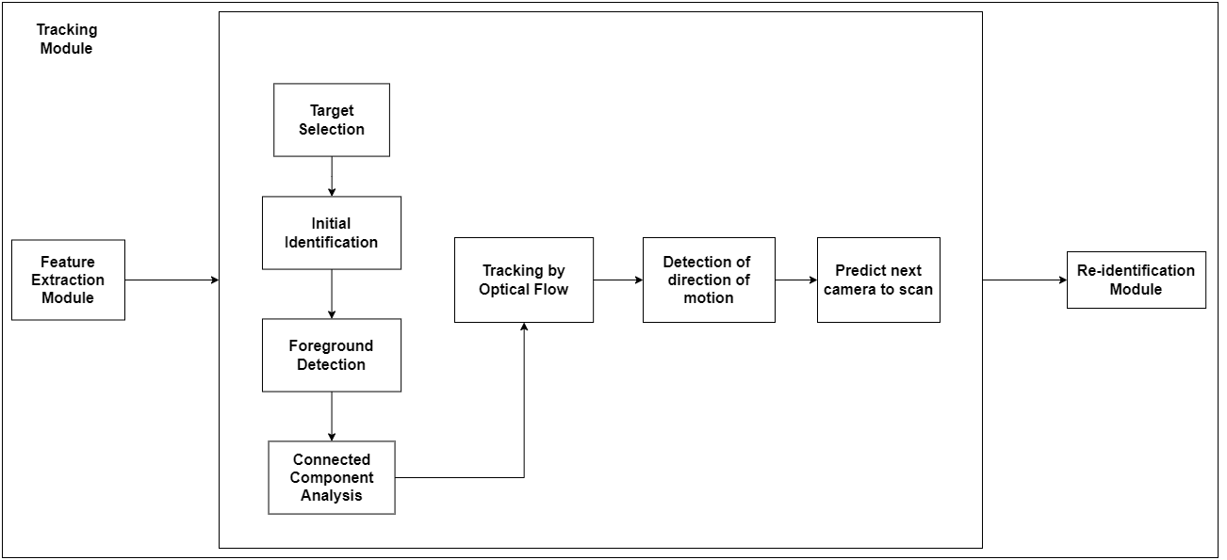

**Figure 3: Modular Diagram of Tracking Module**

This module serves the purpose of Tracking a car within the same video (inter-frame tracking). The target car features from the previous frame are then used for identification of the same car in the next frame. It goes through the following steps.

* **Initial Identification:** The module starts by identifying and tracking objects in one video frame. This initial identification may involve detecting cars or other objects in the frame and assigning unique identifiers or labels to them.
* **Foreground Detection:** It may perform foreground detection to isolate moving objects from the static background. This step helps in distinguishing the objects of interest (e.g., cars) from the background.
* **Connected Flow Analysis:** The module analyzes the flow of connected objects across frames. It tracks how objects move from one frame to the next, allowing it to follow the trajectory of each object.
* **Tracking by Optical Flow:** Optical flow is a technique used to estimate the motion of objects in consecutive video frames. It calculates how pixels move between frames, helping to track the objects' positions accurately over time.
* **Detection of the direction of motion:** The direction of motion of the car helps in identifying the next camera or the set of cameras that might have captured the car. The direction of motion is calculated using vector mathematics.

**Re-Identification Module:**

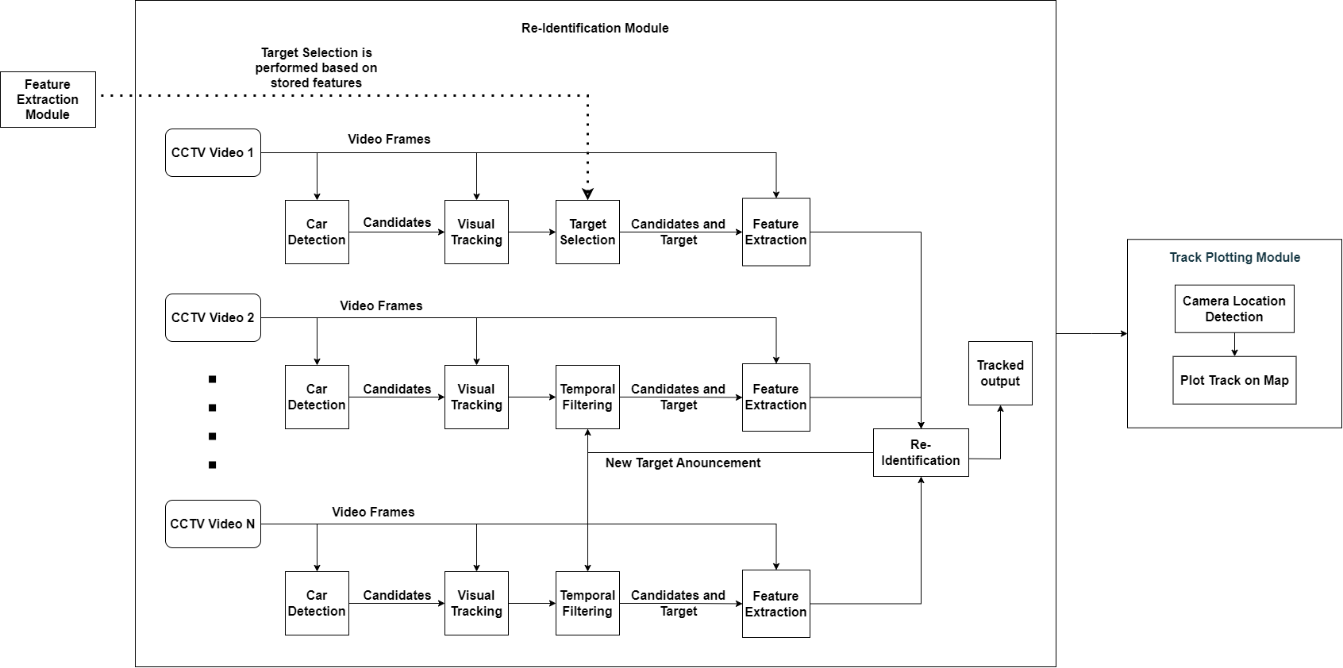

**Figure 4: Modular Diagram of Re-identification Module**

This module handles the process of re-identifying the subject car between distinct camera footage. Utilizes the feature vectors calculated in the previous module for comparison. It compares the active target with all candidates from each camera. Provides a sorted list of potential candidates along with different scores for each candidate. It subscribes to video frames (optional) and receives candidates and targets from the Feature Extraction module. Outputs new target announcements and re-identification results which are used to track the re-identified subject car in the new camera.

**Candidate Detection:**

* It focuses on detecting cars within video frames.
* It receives video frames as input and identifies potential candidates (cars).
* It generates and shares the locations of these candidates within individual frames.

**Candidate Filtering:**

* The purpose is to further process the candidates before re-identification.
* It may perform tasks such as tracking or grouping of detected individuals believed to be the same car.
* Optionally, it can subscribe to new target announcements from the Re-identification module.
* It acts as a temporal filter for potential candidates.
* This module subscribes to video frames (optional), candidates from the Candidate Detection, and   
   new target announcements (optional).
* It outputs candidate and target locations.

## 4.3 Methodology used

The methodology of the project is as follows:

**Video Processing Module**

In the video processing module video from CCTV is uploaded to the system and then video processing is done, where the frames are converted from the video and stored in one folder.

**Object Detection Module**

Each frame undergoes analysis in the object detection module, if any particular frame does not contain objects(cars) then delete the frame. This helps to reduce the complexity in cases of no vehicles in videos. The module uses the YOLO model for vehicle detection. Then after cleaning through the frame data the system starts detecting cars in each frame and creates a bounding box that crops the cars from the frame. The cropped cars are stored in another folder. Additionally, the cropped cars are checked with a number plate in the frame, if a number plate is detected then these number plates are also cropped and stored.

**Feature Extraction Module**

The cropped cars and number plates are sent to extract the features of the car such as car model, color, texture and number plate. This feature extraction is done with the user input image also. Car models and colors are extracted using the CNN model EfficientNet B1. The cropped number plates are passed under OCR.

* **EfficientNet:** EfficientNet is a convolution neural network that works on the concept of compound scaling. The compound scaling method is based on the idea of balancing dimensions of width, depth, and resolution by scaling with a constant ratio. This capability allows the system to train the model efficiently, minimizing any additional loss during the training process. Our dataset is employed for training models specifically designed for car color and model classification. The training process involves instructing the model to classify cars into distinct color classes and model classes.
* **Easy OCR:** Easy OCR is a font-dependent printed character reader based on a template-matching algorithm.

**Tracking Module**

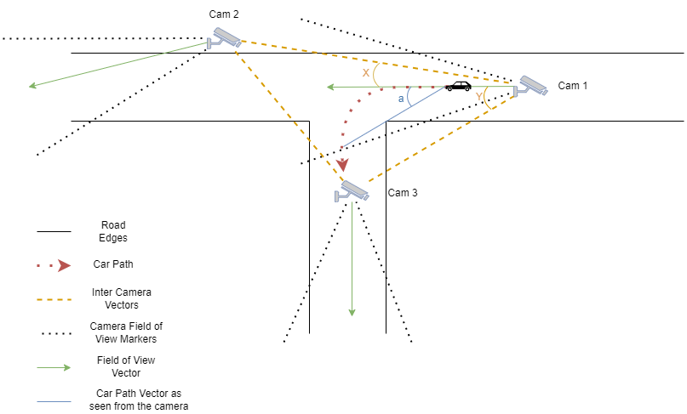

**Figure 5: Vector mathematical technique for camera selection**

This is the most important module as it produces the tracking results that help the officials find the stolen vehicle. The tracking is split into three parts, the car direction detection, the next camera decision-making, and the track plotting.

* **DeepSORT:** DeepSORT, or Deep Learning-based Object Tracking, is an advanced algorithm for multi-object tracking. It integrates deep neural networks for object detection and tracking, enhancing traditional SORT (Simple Online and Realtime Tracking) by associating detected objects over consecutive frames using learned features. DeepSORT excels in crowded scenes and occlusions, vital for surveillance and autonomous systems.

The DeepSORT produces a path for every car detected in the video. Using the extracted features in earlier stages, we identify the subject car and extract the tracked path coordinates produced by DeepSORT. These coordinates are used to determine the direction the car moves in the video.

* **Car Direction Detection:** The process starts by scanning through the CCTV camera footage of the nearest camera from the location of the theft. Once the suspect vehicle is identified in the footage, it is tracked using an object tracking algorithm, ‘DeepSort’, to produce a track of the path traveled by the vehicle as seen by the camera. We use the first and last coordinates of the centroid center of the car bounding box and create a vector. This vector is compared with the direction vector of the field-of-view of the camera to decide whether the car takes a turn in a specific direction or moves straight.
* **Next Camera to Choose:** Direction vectors between cameras (inter-camera vectors) are created beforehand using the latitude and longitude of each camera. For each inter-camera vector between the current camera and the neighboring cameras, its angle with the direction vector of the current camera is found. These angles are compared with the angle between the car direction vector and the field-of-view vector of the camera. Next camera is chosen based on the least difference between these two angles in the appropriate direction.
* **Track plotting:** The above process is applied to subsequent cameras to track the car as far as possible in the CCTV network. Finally, the track is created using the geolocations of each camera that tracked the subject car to produce a complete route map of the path taken by the car. This route is plotted using map APIs like Google Maps.

# 5. Testing of the Proposed System

## 5.1 Types of Test Considered

Use Case: Candidate Car Detection

Method used:- Yolov5

Input:- Video frames

Expected output:-Bounding Boxes surrounding all the cars present in the frame with 100% accuracy.

Actual output:-Bounding Boxes surrounding all the cars present in the frame with 100% accuracy.

Result:- Pass

Use Case:- Number plate Detection

Method used:-Yolov5

Input:- Cropped car image

Expected output:-Bounding Boxes surrounding the license plate with 100% accuracy.

Actual output:-Bounding Boxes surrounding the license plate with 100% accuracy.

Result:- Pass

Use Case: OCR detection on number plate

Method used:- EasyOCR

Input:- Cropped Number plate image

Expected output:- Extracting the license number with 90% accuracy

Actual output:- Inaccurate results of number plate with accuracy below 50%

Result:- Fail

Reason:- EasyOCR unable to detect because the numberlate extracted were skewed

Measure:- Desqewing the number plate

Expected output:- Extracting the license number with 90% accuracy

Actual output:- Extracted the license number with 90% accuracy

Result:- Pass

Use Case:- Detecting the color of car

Method used:- K-Means clustering

Input:- Cropped car image

Expected output:- Color of the car with above 90% accuracy

Actual output:- Inaccurate results for the Color of the car with accuracy below 70%

Result:- Fail

Reason:- Difficult to get the color differentiating boundaries

Measure:-Efficient-Net

Expected output:- Color of the car with above 90% accuracy

Actual output:- Color of the car with above 90% accuracy

Result:- Pass

Use Case:- Detecting the model of car

Method used:- Efficient-Net

Input:- Cropped car image

Expected output:- Color of the car with above 90% accuracy

Actual output:- Color of the car with above 90% accuracy

Result:- Pass

## 5.2. Inference drawn from the test cases

The testing of the proposed system highlights the critical impact of method selection on task accuracy, as evidenced by successful outcomes with YOLOv5 for candidate car and number plate detection contrasted with the challenges encountered using EasyOCR for skewed number plate images. Error analysis underscores the importance of adapting methods to specific challenges, as evidenced by the transition from K-Means clustering to Efficient-Net for accurate color detection. Preprocessing measures such as deskewing improve OCR accuracy, while the robustness of Efficient-Net in detecting both car color and model emphasizes the importance of leveraging resilient methods. The testing process not only identifies areas for improvement but also underscores the necessity of continuous refinement to achieve a robust and reliable system.

# 

# 6. Results and Discussions

We were successful in achieving accurate object detection and feature extraction such as Number plate detection. Moreover, we also performed image enhancement using various super-resolution algorithms like EDSR, LapSRN, etc.

| ***Model_Used*** | AVERAGE of Execution_Time(Sec) | AVERAGE of Input_Image_Size (kb) | AVERAGE of Output_Image_Size (kb) |
| --- | --- | --- | --- |
| Bicubic | 0.003768 | 146.875 | 87.5 |

**Table 1: Analysis of Bicubic Enhancement**

Table 1 shows the average time and average input and output space requirements of the Bicubic Image enhancement technique. Similarly, table 2 shows equivalent measures for Super Resolution algorithms (EDSR and LapSRN) at different enhancement levels.

| ***Model_Used*** | AVERAGE of Execution_Time(Sec) | AVERAGE of Input_Image_Size (kb) | AVERAGE of Output_Image_Size (kb) |
| --- | --- | --- | --- |
| EDSR 2x | 162.135201 | 146.875 | 174.375 |
| EDSR 4x | 166.103579 | 146.875 | 264.25 |

**Table 2: Analysis of EDSR Super Resolution**

| ***Model_Used*** | AVERAGE of Execution_Time(Sec) | AVERAGE of Input_Image_Size (kb) | AVERAGE of Output_Image_Size (kb) |
| --- | --- | --- | --- |
| LapSRN 2x | 2.287813 | 146.875 | 176.75 |
| LapSRN 4x | 10.475022 | 146.875 | 420.5 |
| LapSRN 8x | 43.696687 | 146.875 | 1097.75 |

**Table 3: Analysis of LapSRN Super Resolution**

Following are the intermediate stages of processing. Figure 6 shows the detected car image that was cropped from the original frame shown in Figure 5.

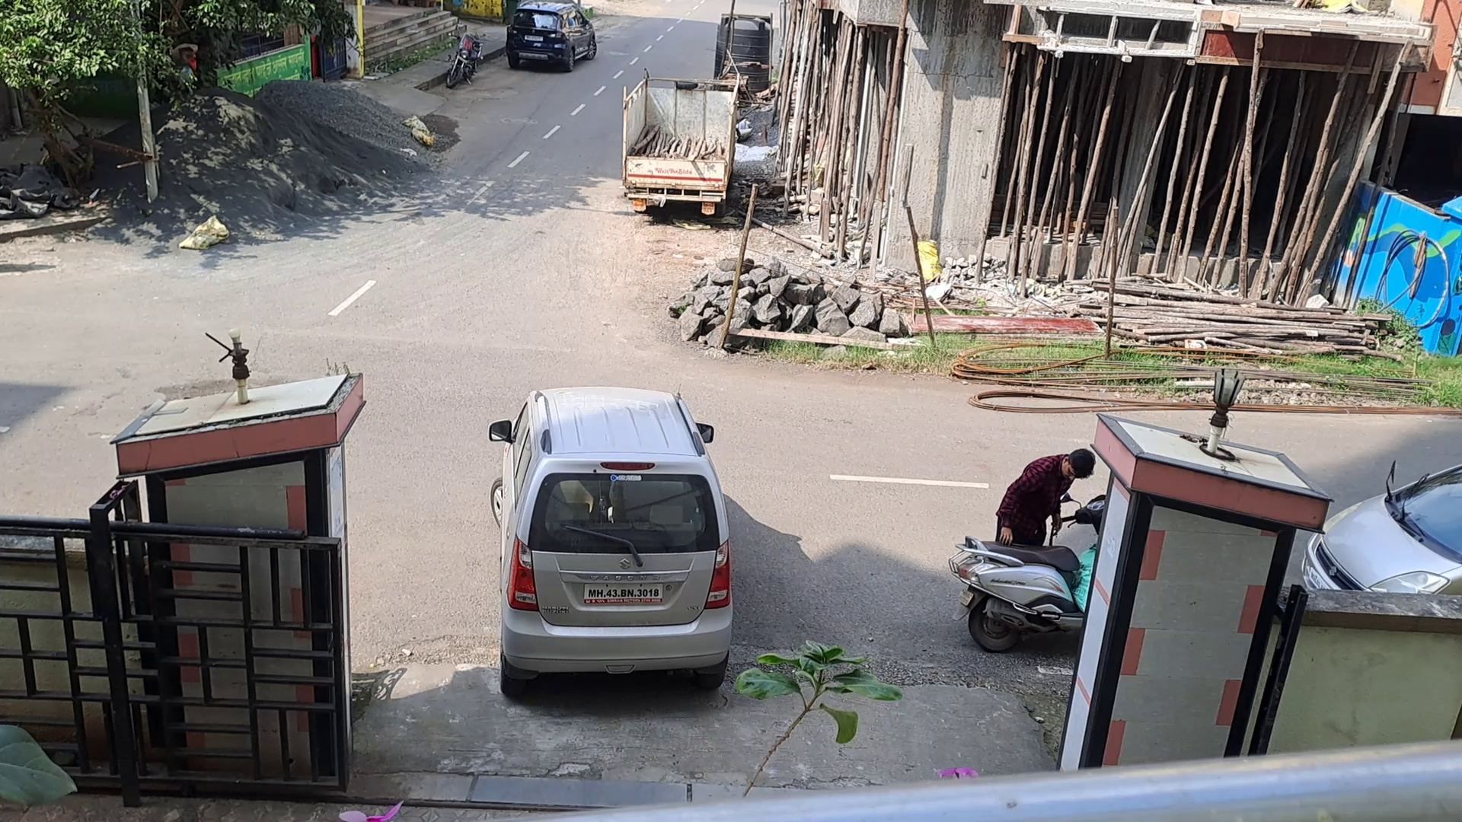 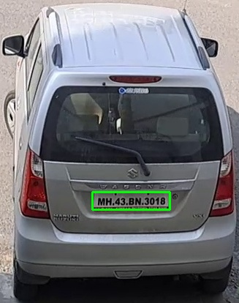

**Figure 6: Video Frame and Cropped image of detected car from input frame**

Figure 7 shows the cropped number plate image from the originally cropped car image.



**Figure 7: Cropped number plate image from cropped car image**

Figure 8 shows the results of OCR performed on the cropped number plate image. The results of OCR before and after deskewing.

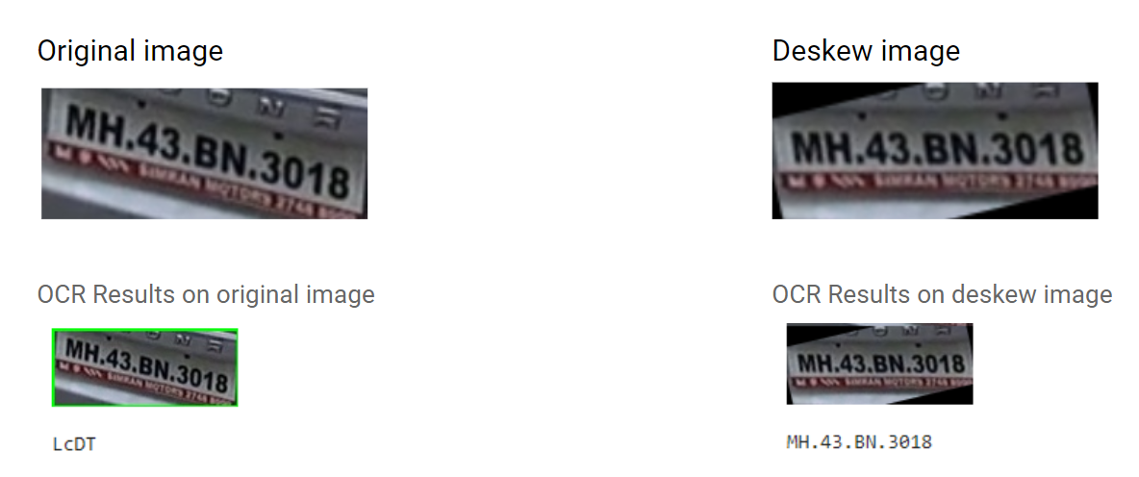

**Figure 8: OCR Result on cropped number plate image (before and after deskewing)**

Figure 9 shows the training and validation results of the EfficientNet-B1 model trained on a dataset containing 4000 images for 2 cars (Swift and WagnoR). The graphs display training and validation accuracies of above 0.9, with a low training and validation loss of less than 0.2. This ensures good model training for predicting car models.

# 

**Figure 9: Training and validation results for car model prediction model.**

Figure 10 showcases the prediction of the car model given by our model on unseen images.

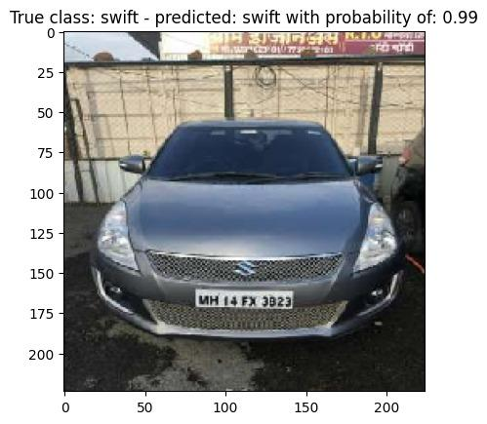 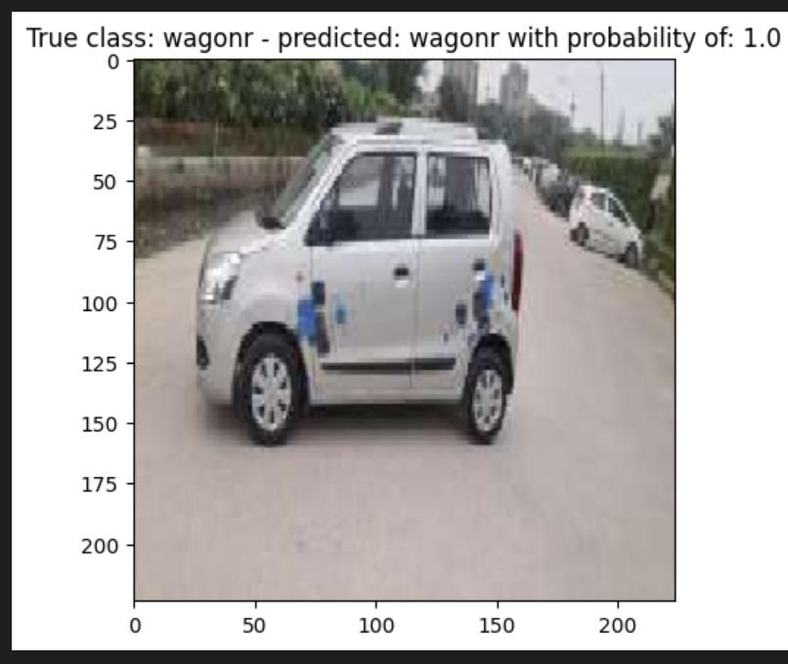

**Figure 10: Results of car model recognition**

Figure 11 shows the training and validation results of the EfficientNet-B1 model trained on a dataset containing 3753 images for 8 cars' color classes (black, blue, red, white). The graphs display training and validation accuracies of almost 0.9, with a low training and validation loss of less than 0.5. This ensures good model training for predicting car models. Figure 9 showcases the prediction of the car model given by our model.

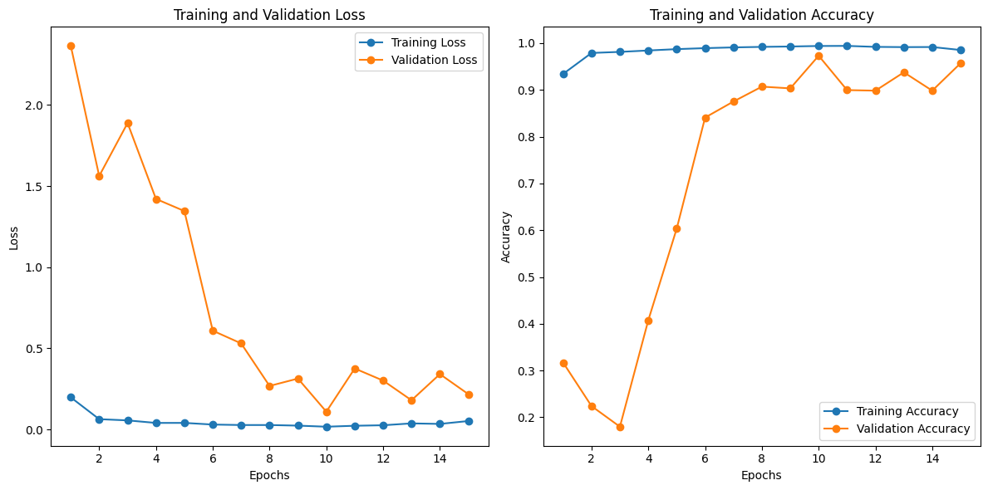

**Figure 11: Training and validation results for car color recognition model.**

Figure 12 showcases the prediction of the car color given by our model on new images.

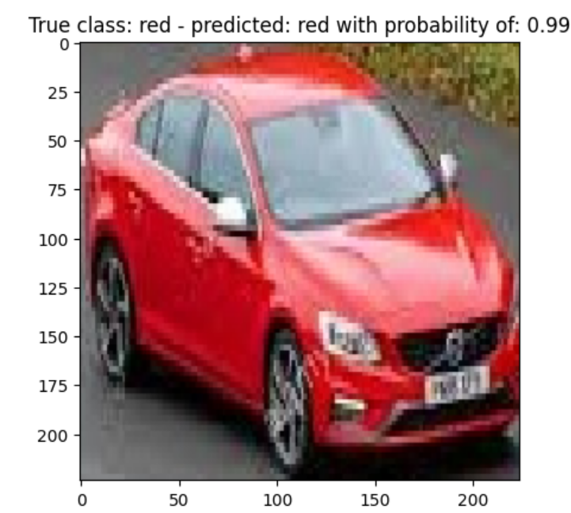 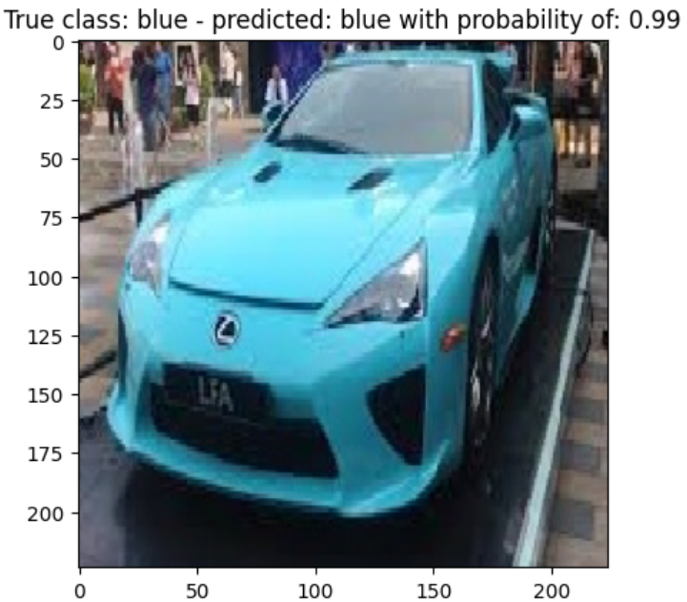

**Figure 12: Results of car color recognition**

Figure 13 shows the application of the DeepSORT algorithm on the video extracted from CCTV footage. The result shows the path, as tracked by the algorithm, taken by the car under observation as seen in the video.

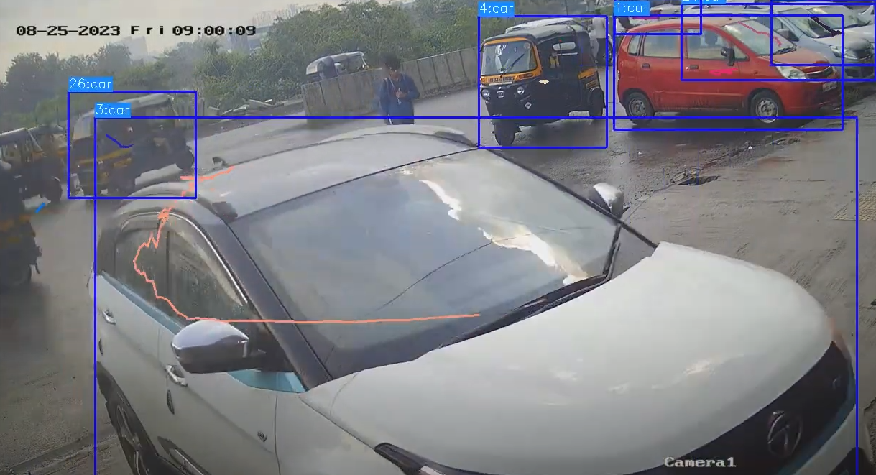

**Figure 13: Tracking results of DeepSORT**

Table 4 shows the execution time comparison of the complete pipeline using CPU and GPU, tested on 3 videos of varying file size and length.

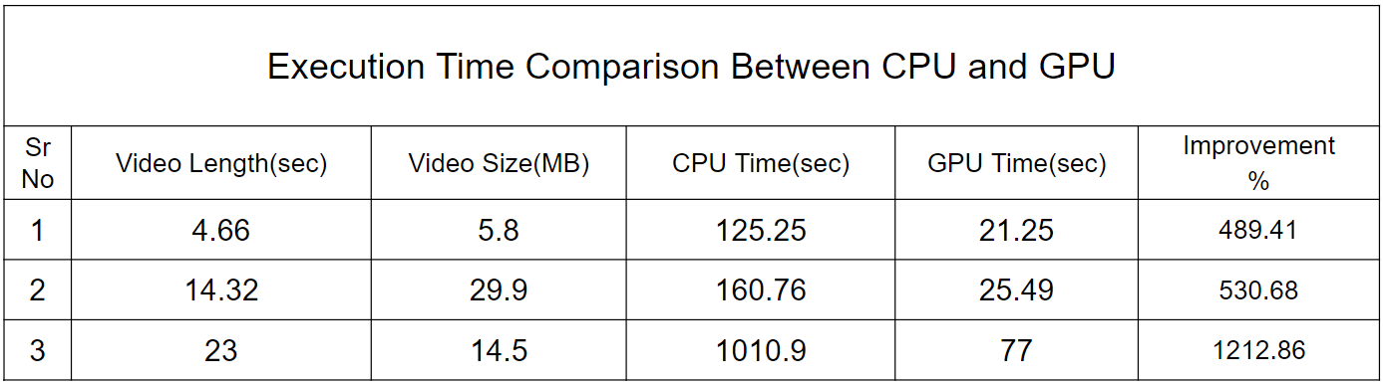

**Table 4: CPU vs GPU execution time comparison**

# 

# 

# 7. Conclusions

In our comprehensive investigation, we delved into a diverse array of image enhancement methodologies, spanning traditional image alteration techniques and sophisticated deep learning algorithms. Our exploration was motivated by the profound importance of Closed-Circuit Television (CCTV) cameras, which leverage state-of-the-art technologies like computer vision and artificial intelligence (AI) to swiftly identify missing objects and individuals. Recognizing the indispensable role played by these technologies in modern surveillance and public safety, we embarked on a mission to amplify their efficacy through innovative collaboration and skillful application.

Through our collective expertise and ingenuity, we envision a future where the synergy of pioneering ideas and specialized skill sets leads to profound advancements in real-world problem-solving. By harnessing the power of image enhancement techniques and integrating them with cutting-edge AI-driven approaches, we aim to revolutionize the effectiveness of surveillance systems in locating missing items and individuals. This collaborative effort is not merely about technological advancement; rather, it embodies a commitment to societal welfare and compassion.

By streamlining the process of locating missing objects and individuals, our endeavors promise to bring about tangible benefits to society at large. Whether it's expediting search and rescue operations or facilitating the recovery of lost possessions, our concerted efforts pave the way for a more efficient, humane, and responsive approach to addressing such challenges. Ultimately, our work is driven by a shared aspiration to make a meaningful difference in the lives of people, fostering a safer and more compassionate world for all.

# References

| [1] | https://auto.economictimes.indiatimes.com/news/aftermarket/vehicle-theft-increases-by-2-5x-in-india-in-2023-delhi-tops-the-list-acko-report/108454773?utm_source=copy&utm_medium=pshare |
| --- | --- |
| [2] | K.V. Kadambari, et.al. "Deep Learning Based Traffic Surveillance System For Missing  and Suspicious Car Detection", 2020 |
| [3] | Xiying Li et.al. "Object Re-Identification Based on Deep Learning",2019 |
| [4] | Anil Sharma, et.al. "Intelligent Camera Selection Decisions for Target Tracking in a Camera Network", Indraprastha Institute of Information Technology (IIIT), Delhi,2022 |
| [5] | Antonius Herusutopo, et.al. "Recognition Design Of License Plate And Car Type Using Tesseract Ocr And Emgucv",Information Systems Department, School of Information Systems, Bina Nusantara University,2012 |
| [6] | D. F. Llorca et.al. "Vehicle model recognition using geometry and appearance of car emblems from rear view images". 2014 |
| [7] | Delong Cai et.al. "Corner-Point and Foreground-Area IoU Loss: Better Localization of Small Objects in Bounding Box Regression",School of Electrical Engineering and Intelligentization, DongGuan University of Technology, 2023 |
| [8] | Shailendra Shende et.al. "CNN based Missing Object Detection",Government College of Engineering Chandrapur, 2023 |
| [9] | Zhenyu Zhang, Haotian Zhang, and Xiaolin Huang, "Deep Object Detection in Urban Surveillance Environments," School of Electrical and Computer Engineering, Oklahoma State University, 2022. |
| [10] | Jiawei Chen, Xiaoxiao Fu, and Zhiguo Cao, "A Novel Approach to Missing Object Detection Using Semantic Segmentation and Deep Learning," School of Computer Science and Technology, Harbin Institute of Technology, 2022. |
| [11] | Pier Matteo Barone,Rosa Maria Di Maggio and Silvia Mesturini et.al. "Materials for the study of the locus operandi in the search for missing persons in Italy",American University of Rome, 2021. |
| [12] | Tingwei Zhang, Qixiang Ye, and Liang Xie, "Efficient Missing Object Retrieval in Large-Scale Surveillance Databases using Siamese Networks," School of Computer Science, Beijing Institute of Technology, 2021. |
| [13] | Xin Li, Shengfu Zhai, and Xiaoli Zhang, "Real-time Missing Object Detection in Crowded Environments using Deep Learning," School of Electronics Engineering and Computer Science, Peking University, 2021. |
| [14] | Prof. M. Seshaiah, Abhijith R Nair, Ektha Mallya, Shiv Dev et.al. "CCTV Surveillance Camera’s Image Resolution Enhancement using SRGAN",VTU, Belgaum, India,2020 |
| [15] | Haiyang Pan, Xiaowei Guo, and Liangjian Chen, "Enhancing Object Detection in Challenging Conditions: A Comparative Study," School of Information Science and Engineering, Shandong Normal University, 2020. |
| [16] | Zhong-Qiu Zhao, Member, IEEE, Peng Zheng, Shou-tao Xu, and Xindong Wu et.al. “Object Detection with Deep Learning: A Review”, 2019. |
| [17] | Chunhua Shen, Xinchao Wang, and Yuning Jiang, "Missing Object Detection in Complex Scenes using Graph Neural Networks," School of Computer Science, The University of Adelaide, 20 |
| [18] | Jamal Raiyn et.al. “Detection of Objects in Motion—A Survey of Video Surveillance'', Al Qasemi College, 2013 |
| [19] | How To Find A Stolen Car In 3 Steps (https://alfred.camera/blog/how-to-find-a-stolen-car/) |

# Appendix

**A.1 Data Collection and Preprocessing**

**A.2 YOLO Object Detection Algorithm**

**A.3 License Plate Recognition**

**A.4 Privacy-Preserving Measures**

**A.5 Integration and Real-World Implementation**

**A.6 Challenges and Future Improvements**

**Achievements**

**Sem 7 Review 1 Score**

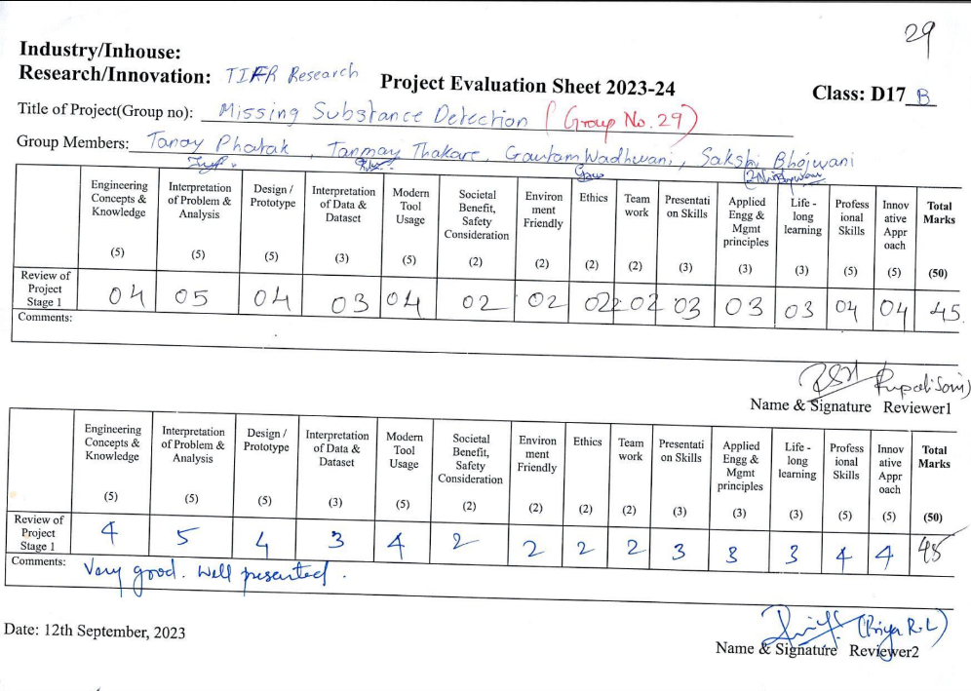

**Sem 8 Review 1 score**

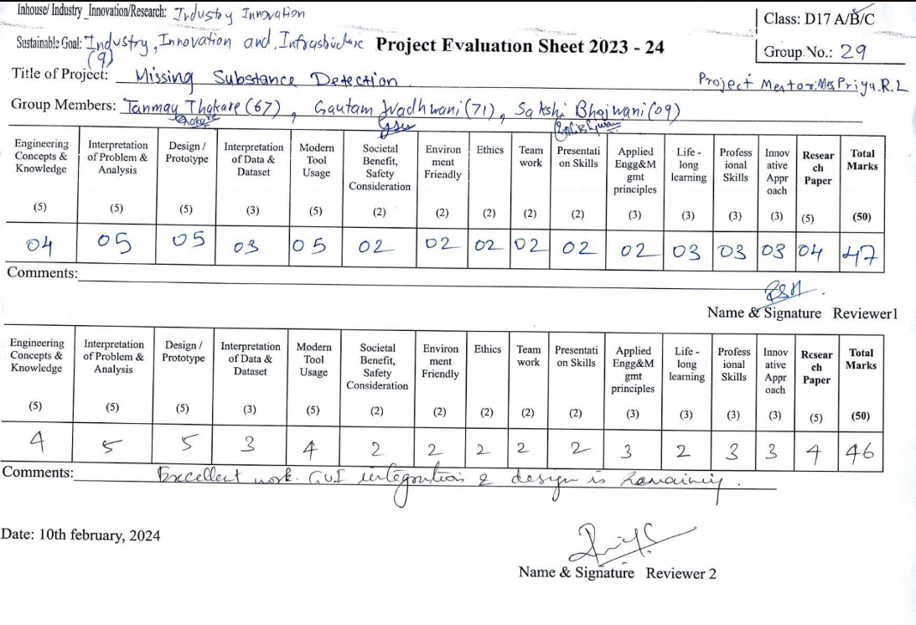

**Sem 8 Review 2 score**



**Technology Day Certificates:**

Tanay Phatak

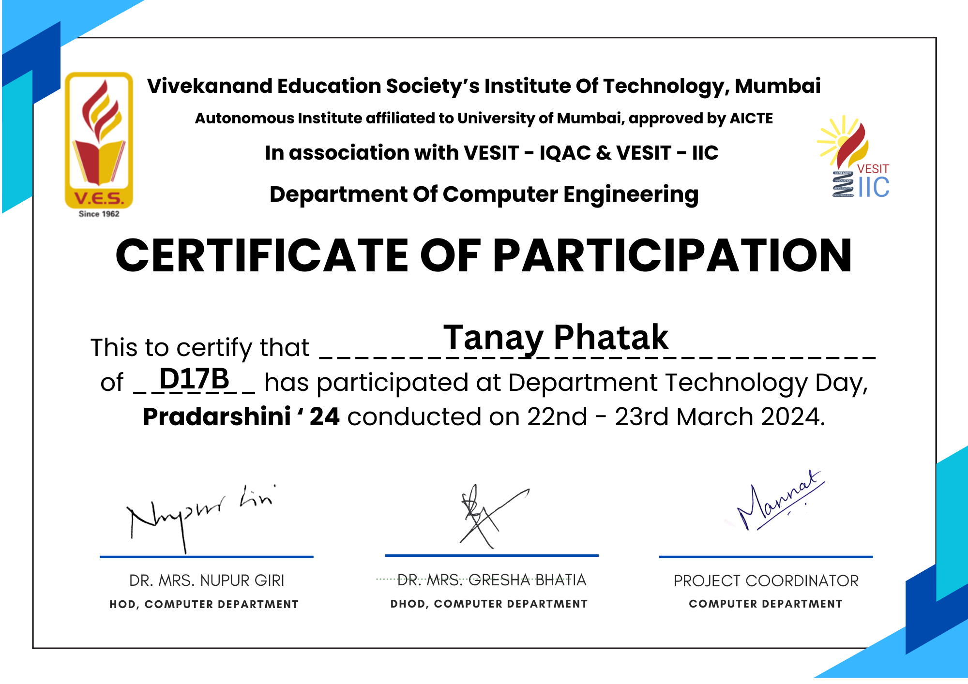

Gautam Wadhwani

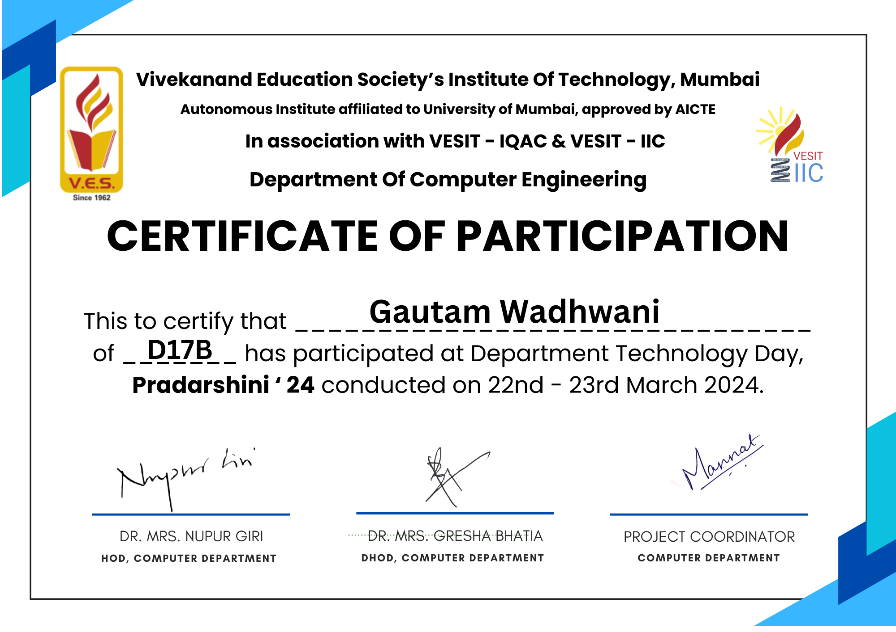

Tanmay Thakare

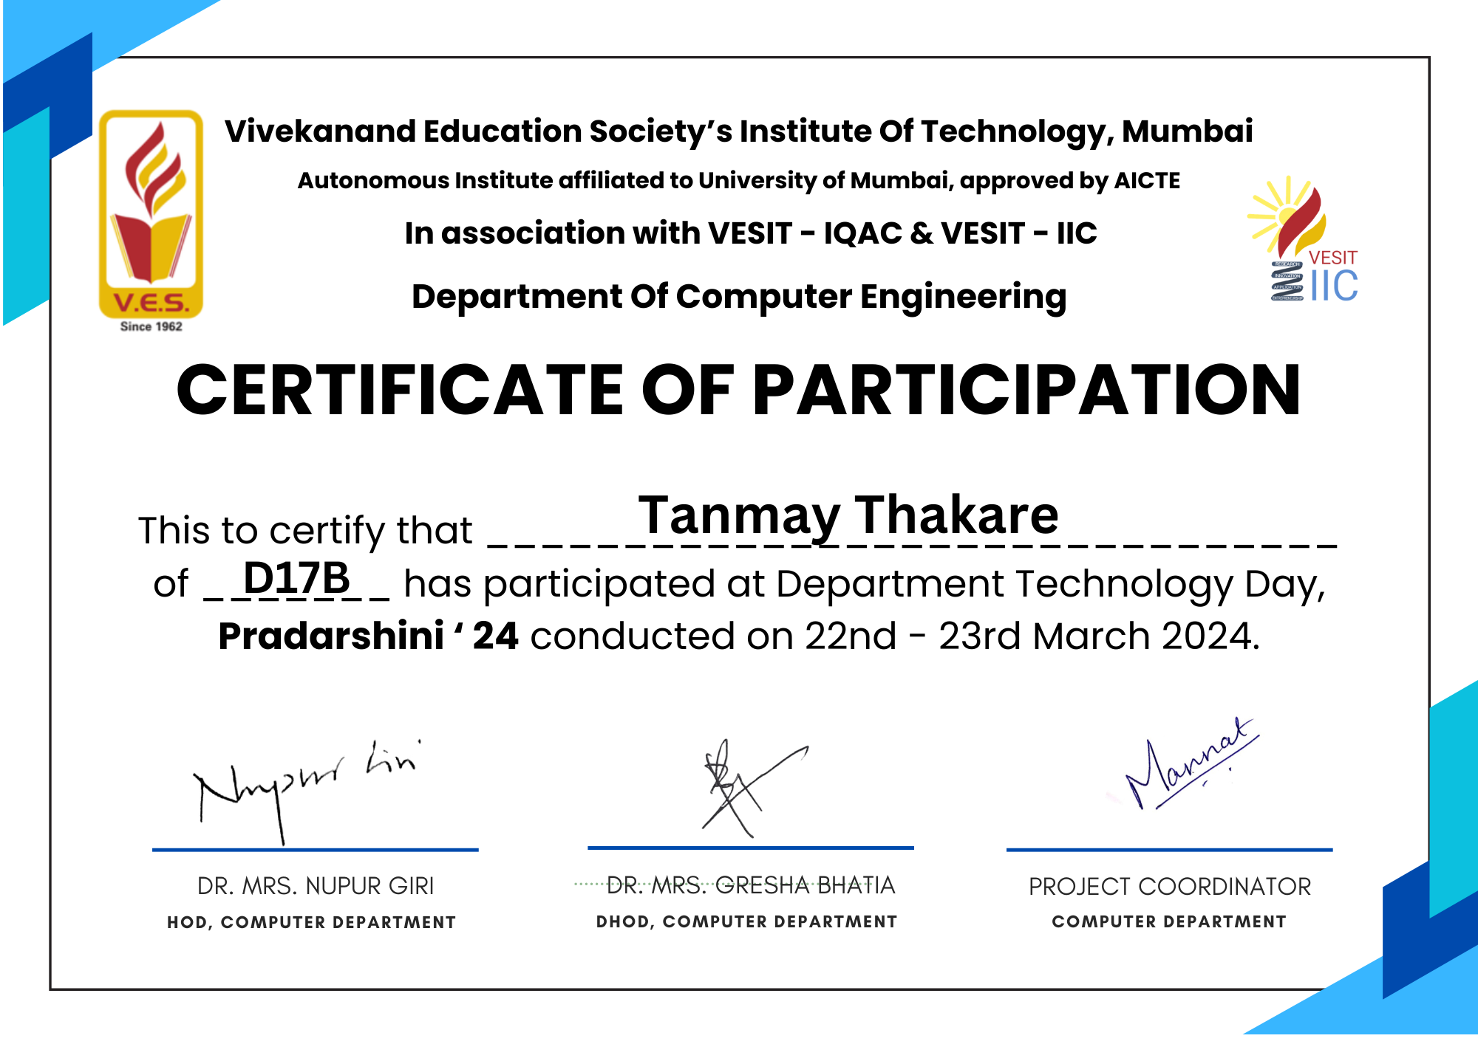

Sakshi Bhojwani

